Title: | Window Lifter  SW Component Window Lifter

History
Issue status  (Index) | Maturity/Date  (draft/invalid/valid)  (dd-mmm-yyyy) | Author  CES | Check/Release  CES | Description  First edition
1.0 | Valid  20-July-15 | Mario Rivera | Mario Rivera | Design Window Lifter.
1.1 | Valid  23-july-15 | Edgar Mosqueda |  | Add diagrams.

Table of Contents
1 Purpose 3
2 Definitions and abbreviations 3
3 Realization constraints and targets 3
4 SW Conceptual design 4

4.1 Component diagram…………………………………………………….

4.2 Use case diagram…………………………………………………

4.3 State diagram…………………………………………………….

4.4 Sequence diagram……………………………………………

4.5 Activity diagram……………………………………………………
5 SW Component internal breakdown 5
5.1 Functional Decomposition 5
5.2 Function void Task_1ms (void) 6
5.3 Function void Task_10ms (void) 7
5.4 Function void Show_Leds(void) 7
5.5 Function void machine(void) 8
5.6 Function void Sed_Direction (void) 9
5.7 Function void Sed_Mode(void) 10

Purpose
This document has been created to show how Window Lifter module works. Window lifter is the module responsible to control the window movement. We have identified each functionality it means, separate two movements (Up/Down) and anti-pinch functionality. According to requirements, we have implemented two machines states to controlled direction window and velocity of each transition.

Definitions and abbreviations
Definitions
Window Lifter  Anti-Pinch | The head module to lower or raise the car windows and anti-pinch functionality  Anti-pinch is a functionality that prevents any accident with human limb.
SW | Software.

Abbreviations
GPIO General Purpose Input/output
PIT Periodic Interrupt Timer
References
N° | Document name | Reference
1 | Window Lifter requirements
2 | AEP RTOS

Realization constraints and targets

In this module we have some constraints. To simulate the window movement, we use a led bar with 10 leds. The transitions between transitions is 400ms. We have two movements, Up and Down. To validate button push, needs to keep pressed more than 10ms. We have to indicate the movement (Up or Down) trough led color. We have to cases: Automatic and Manual for each movement button. Automatic mode is when you keep pressed the button between 10ms and 500ms. Manual mode is when button keep pressed more than 500ms. In another case is Anti-pinch mode, this is when the up movement is happen. When this occurs and a human limb is in the windows. Anti-pinch starts and stopping window up movement and starts down until the window is totally open.

SW Conceptual design
For easy understanding the system, it has created from diagrams that it show the structure and behavior that’s why is dividing in blocks, use case, state, sequence, collaboration, component and activity diagrams, those diagrams will explain the next way.

Component diagram
The SW is structured with layer programing for its portability so easy to other embedded systems, that’s why it has programed in this way. In the following picture is showing the layers diagram and its components.

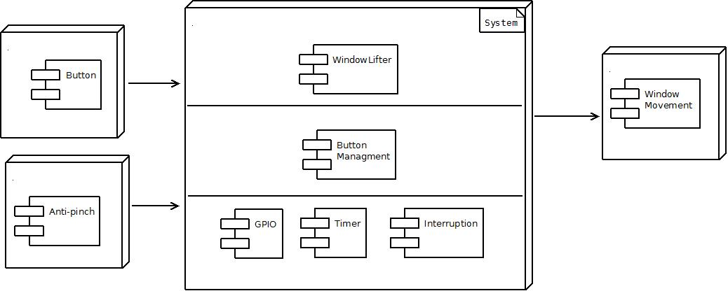

In the before diagram is showing all components into layers and interacts with peripheral systems as button. Button is a signal input and anti-pinch is a signal input too; those signals are processed for system. System has three layers, these contains specific components that are as follows; window lifter is the responsible of the control of window movement, button management is responsible to make the debounce, GPIO, Timer and Interruption are responsible to provide necessary resources for the components window lifter and button management. Window movement is a peripheral indicator in this case is a led bar.

Use case diagram

The following diagram is the use case diagram in this system behavior is defined and how the user interacts with in the situation raised by the requirements.
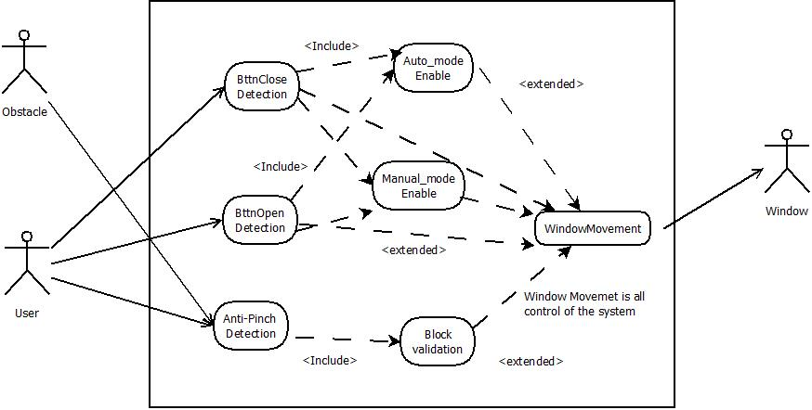

The diagram is represented by three actors, the user actor who will use the benefits offered for the system, the obstacle actor is an obstruction the natural movement of the window, the obstacle maybe is a user or another object and the window actor represents the system that receives the request and responds appropriately.

State diagram

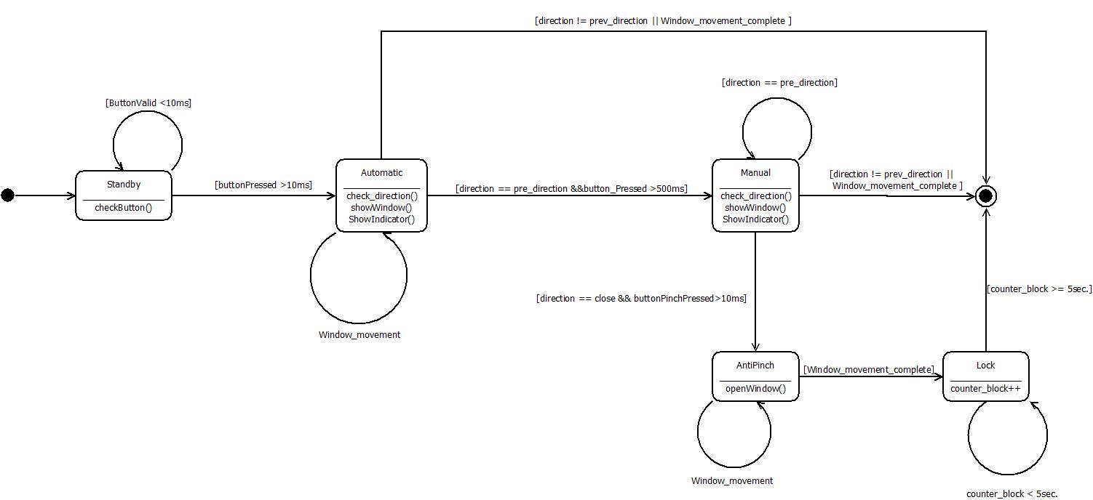

Sequence diagram
In this diagram has shown the interaction between the objects the sequential way and its behavior.

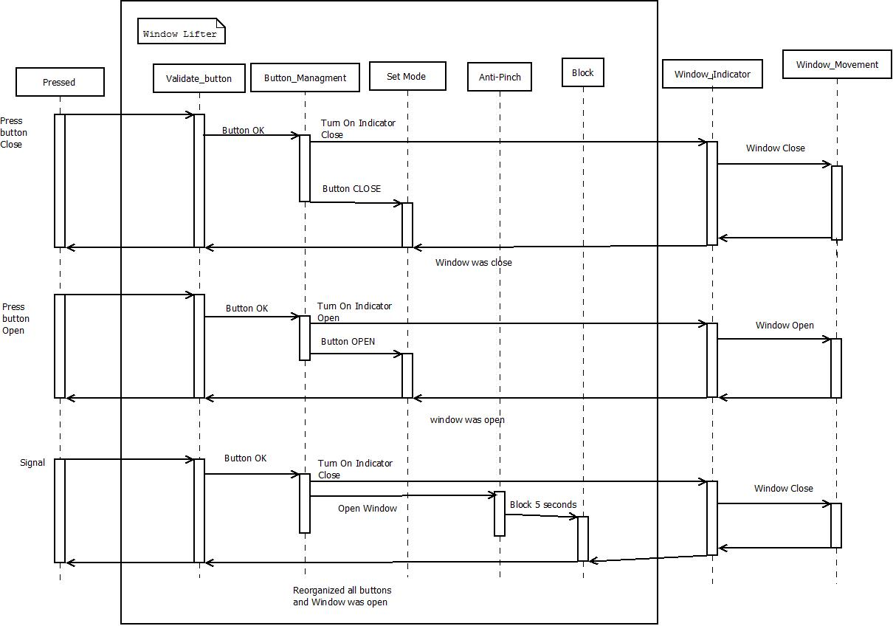

The object "pressed" is external and it's where input signals go to Window Lifter, here it have validated the signal as "button OK" then it pass to "button management" where there is a decision, if is the automatic mode or the manual mode also if is window open or window close while, it turn on a led indicator, all behavior is in "set mode".
The Anti-Pinch feature is in Window Lifter, this feature it has behavior similar to any button that it have to validate that it turn on a led indicator, but only works when is opening window, Anti-Pinch has closed the window after it has make a block to all buttons until 5 seconds for reorganize all buttons

Activity diagram
In this diagram has described the system, its features, the dynamic behavior and its process.

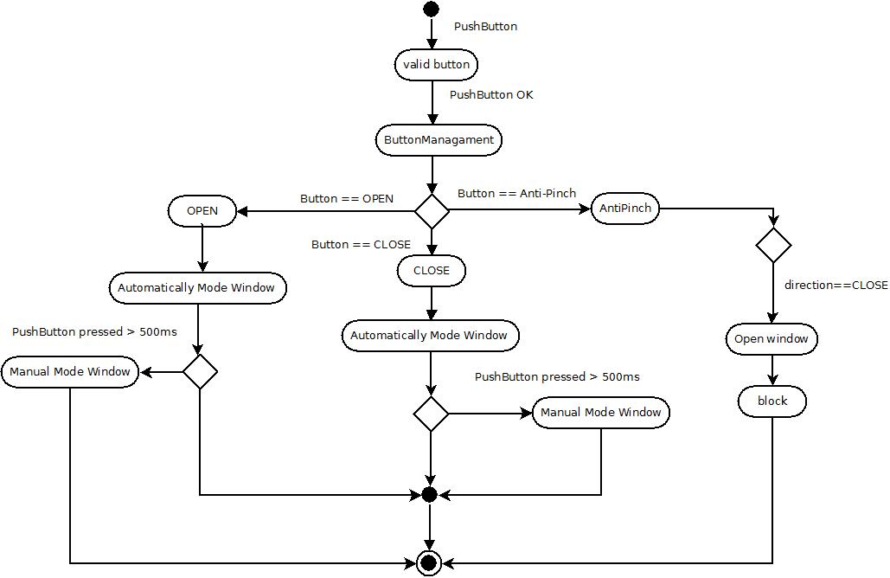

the system start when it has pressed some button, that's pressed as valid then it pass to button management, here there are three possible cases, it can enter open mode, it can enter close mode and it can enter Anti-Pinch.
In open mode has started with the automatic mode until enter a condition that is keeping to press a button than more 500ms for the change to manual mode.
Equally the close mode has started with the automatic mode until enter a condition that is keeping to press a button than more 500ms for the change to manual mode.
in Anti-Pinch is special feature, this has reviewed a condition, if the direction is equal to close then it open window and it make a block of all buttons until after 5 seconds for reorganize all buttons.

SW Component internal breakdown
In this part we going to specify each sub-module used in the window lifter module.
According to requirements, we split the module in sub-modules.
- A general function that controls all flow program. We call this function each mili second to check some counter, which button was pressed and if it meet time requirements (more than 10ms) and call to other functions.
- A specific function that checks if the button was pressed more than 10 ms and return true or false depending on the case.
- A little module that turn on/off leds ( checking what led has to turn on/off)
- A machine of states. In this function we check: first, the transition between leds. Second, wich mode is activated (Manual, Automatic, Anti-pinch or do not do nothing)
- Selection direction. In this part we see which movement have to do (Open or Close) and calculated what led has to be turn on/off and send to respective function.
- A function that sets which mode will be used, Manual, Automatic or Standby.

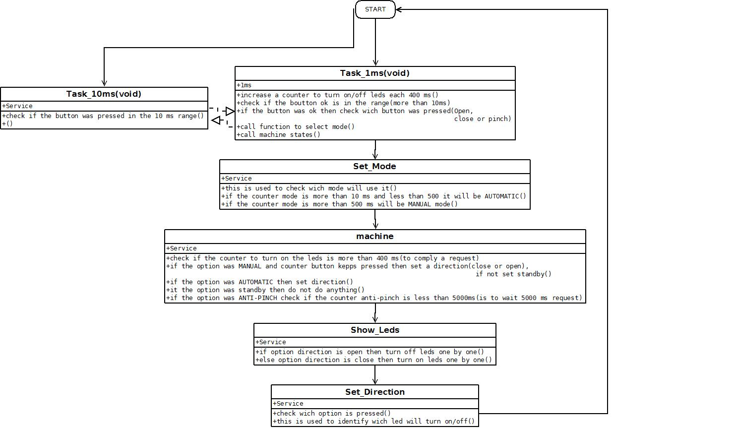
Functional Decomposition

Function void Task_1ms (void)

Description | Functions that controls all program flow
Parameter 1 | void
Return Value | void
Precondition | This function will call when an interruption occurs
Post condition
Error Conditions

Function void Task_10ms (void)
Description | Function to checks validate buttons.
Parameter 1 | void
Return Value | void
Precondition | This function will call each 10ms
Post condition | Sets if a button was pressed “ok”
Error Conditions

Dynamic Behavior
In this functions we check if any button was pressed in the meet requirement time (10ms ).

Function void Show_Leds(void)
Description | A function that turns on/off leds
Parameter 1 | Void
Return Value | void
Precondition | Firs we have to check which button has to turn on/off
Post condition
Error Conditions

Dynamic Behavior
In this function only we’ll turn on/off de indicate led.

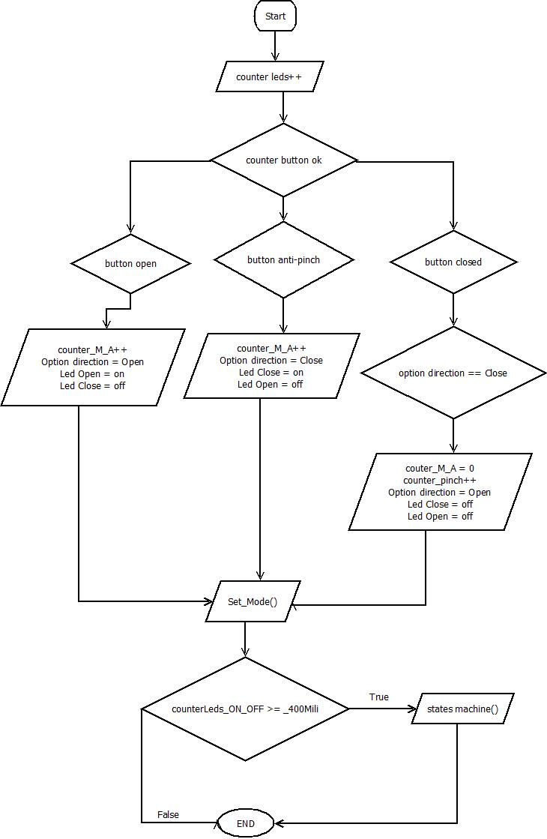

Function void Set_Direction (void)
Description | A function that sets a direction (close or open the window)
Parameter 1 | Void
Return Value | void
Precondition | First we check any direction vali( avoid combination button pressed)
Post condition
Error Conditions

Dynamic Behavior
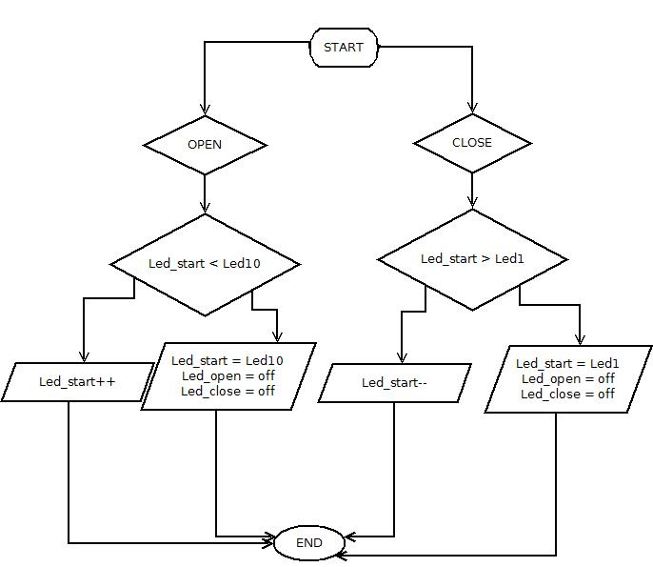

Function void Sed_Mode(void)
Description | A function that sets a mode (Automatic, Anti-Pinch, Automatic or Manual
Parameter 1 | Void
Return Value | void
Precondition | First we have to detect any presh button then check it
Post condition
Error Conditions

Dynamic Behavior
Set what we will do when detect a push button valid.

